1. Download Link: <https://get.videolan.org/vlc/3.0.10/win32/vlc-3.0.10-win32.exe>
2. Select the 64 bit version of windows
3. Right click on “vlc-3.0.10-win32.exe” and click on “Run as administrator”

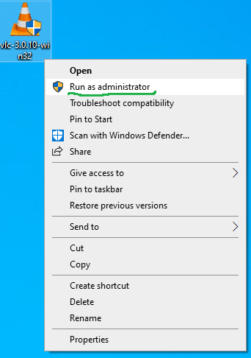

1. Click on Yes

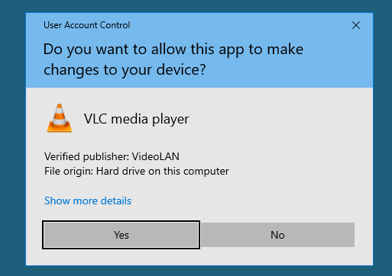

1. Click ok

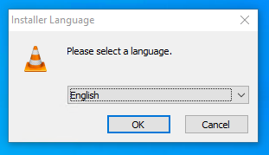

1. Click Next

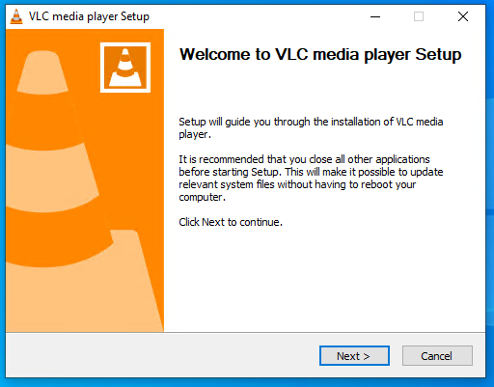

1. Click Next

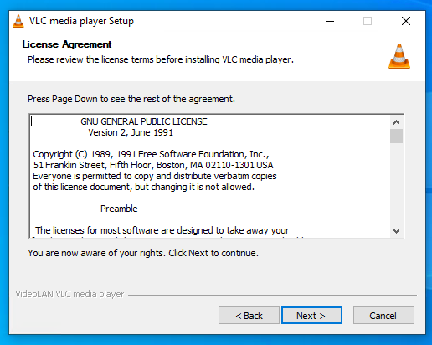

1. Click Next

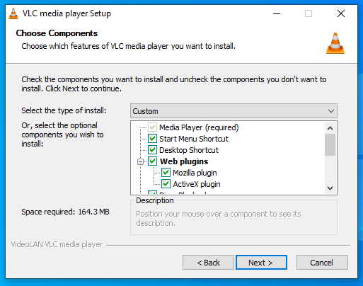

1. Click on Install

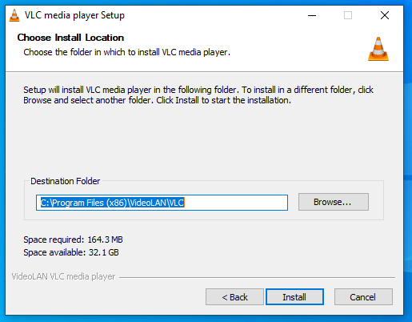

1. Wait for the process to complete

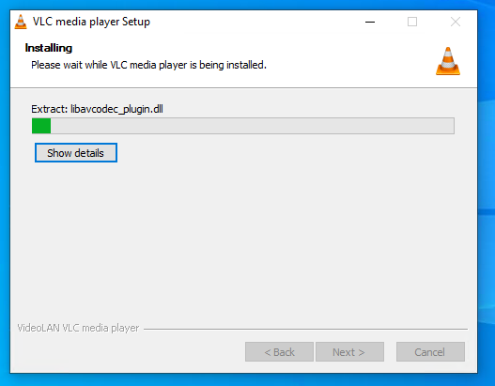

1. Click on Finish

